

PROJECT ASSIGNMENT
NAME: ABHISHEK MORE
ROLL NO.: 20251CIT0063
SECTION: 3CIT02
COURSE: COMPUTER ORGANIATION & ARCHITECTURE
COURSE CODE: CSS 2257
ASSIGNMENT TOPIC: BINARY ALU SIMULATOR
An interactive web simulation of binary addition, subtraction, multiplication and division

Binary ALU Simulator

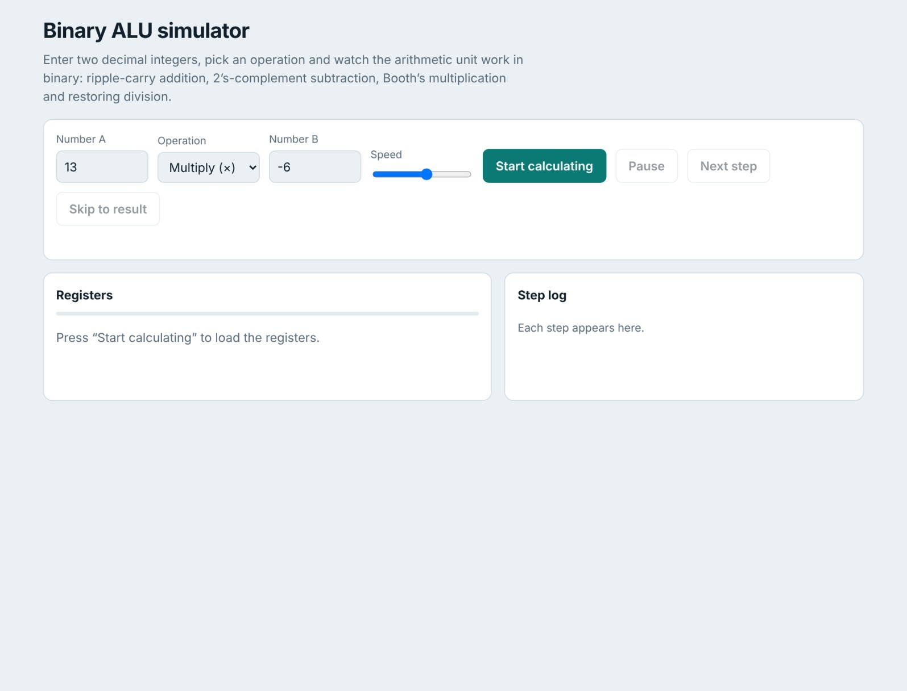

1. Introduction and objectives
Explains how a processor’s arithmetic unit performs addition, subtraction, multiplication and division with simple logic circuits. The slides show this with static diagrams, which makes it hard to see how registers change cycle by cycle. This project turns the slides into a working simulator: the user enters two decimal integers and an operation, the program converts them to binary, runs the same algorithm the hardware would use, shows every step as an animation, and finally converts the binary result back to decimal.
Objectives: accept two decimal integers and one of +, −, ×, ÷; show every step in binary in(registers A, Q, M, carry row); make it feel like a circuit in action (highlights, animation, speed, pause, single-step); show the decimal conversion at the end; and run in any browser from a single file with no libraries.

2. Background theory
n−1
Two’s complement. In an n-bit number the leftmost bit has weight −2 ; negation is “invert all bits and add 1”, so one adder handles signed numbers and subtraction becomes addition.
Full adder and ripple-carry adder. A full adder adds x , y and carry c : s = x y c and c = y c + x c + x y . Chaining n⊕ ⊕ of them gives a ripple-carry adder, whose final carry appears after 2n gate delays. The simulator activates one stage at a time from the least significant bit.

Adder/subtractor. A control line M is XORed with every bit of B and is also the first carry-in. M = 0 gives A + B; M = 1
complements B and sets c = 1, so the adder computes A + BD + 1 = A − B. 0
Booth’s multiplication. For each cycle the pair (Q , Q ) selects the action: 10 → A = A − M, 01 → A = A + M, 00 or 11 → nothing. Then A, Q and Q are shifted right arithmetically (sign bit kept). After n cycles A:Q holds the 2n-bit signed product.
0 −1 −1
Restoring division. A starts at 0, Q holds the dividend and M the divisor (A and M have an extra sign bit). Repeat n times: shift A and Q left; A = A − M; if the sign of A is 1 set q = 0 and add M back, otherwise set q = 1. Q ends as the quotient and A as the remainder.
0
0

3. System design
User input | Validation | Algorithm builder
A, B, operation | range, integer, B≠0 | addSub / booth / divide
 | Player | Steps array S[ ]
Register panel  bit cells, highlight, change animation | timer · next · skip | {phase, text, registers}
 | Step log | Result card
 | appended per step | decimal + binary

The application is one HTML file (structure, CSS and JavaScript) with no dependencies. Its key decision is to record steps, then replay them: each algorithm is a normal function returning an array of steps, where a step holds a phase name, an explanation sentence and a snapshot of the registers to draw. The player just walks through the array, so pause, next and skip are simple and the algorithms can be tested without a screen. The register width is chosen automatically to avoid overflow: add/subtract use max(4, bits of A, B and result); multiply uses max(4, bits of A, B) + 1 (so −M is representable; the product has 2n bits); divide uses max(4, bits of |A|, |B|) on magnitudes with signs fixed at the end.

4. Implementation
Technology: HTML5 for structure, CSS3 (grid, colour tokens, light/dark themes, animations) for presentation, and vanilla JavaScript for the arithmetic, step builder and player. The complete code is in the appendix.
Helpers. bin(v,n) makes an n-bit 2’s-complement string, pi(s) reads bits as unsigned, sb(v) gives the minimum signed width, and dec(s) reads bits as signed while producing the explanation (for example “− 128 + 64 + 8 = −56”).
Addition and subtraction share addSub(A,B,sub). For subtraction it inverts B and sets c = 1. For every stage i it applies the full-adder equations, writes s to the sum row and c 0
to the carry row, and i i+1 records one step with that column highlighted.
const s = xi ^ yi ^ ci; // sum bit
const co = (yi&ci)|(xi&ci)|(xi&yi); // carry out
Booth (booth) keeps M, −M, A, Q and Q . Each cycle records an examine step, an add/subtract step if needed, and a shift right step. Restoring division (divide) records shift left, subtract and decide steps per cycle; the vacated bit of Q shows as a dim dot until it is decided, and division by zero is rejected before any step is built. −1
Player and renderer. The player keeps a step index and a timer whose delay comes from the speed slider (about 0.3– 2.1 s). Pause stops the timer, Next renders one step, Skip renders the rest. The renderer draws each register as bit cells in groups of four; cells in the step’s highlight list are amber, and cells whose value changed since the previous step play a short “pop” animation. Log lines slide in, and the last step reveals the result card.

5. Operation walkthroughs
The examples below are those used in the lecture slides.
7 + 6 (ripple-carry). Five bits are used (X = 00111, Y = 00110). The sum row is built stage by stage; the result 01101 converts to 8 + 4 + 1 = 13.
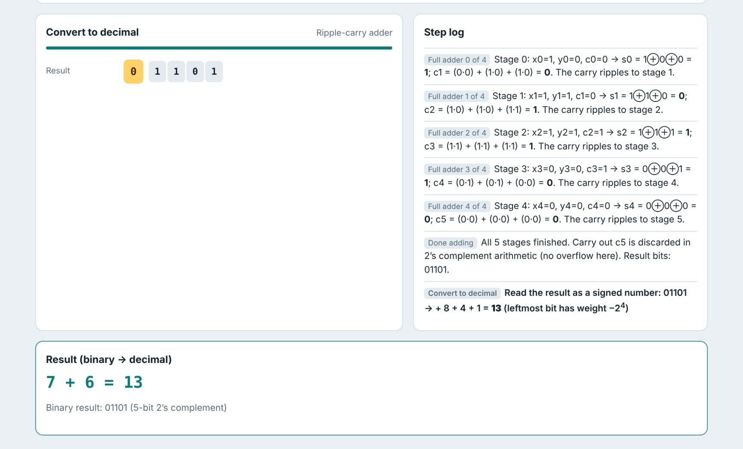

13 − 6. The setup step inverts B = 00110 to 11001 (all cells highlighted) and sets c = 1; the adder then yields 00111 = 7. 0
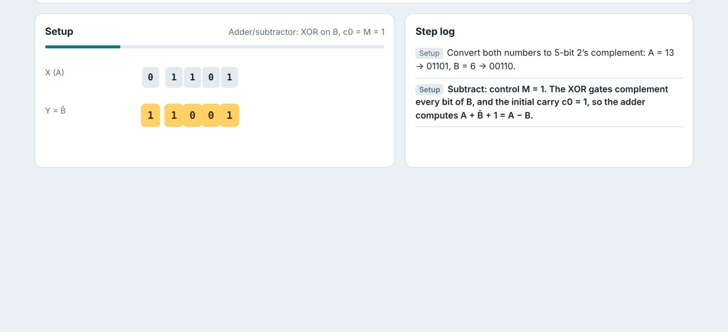

13 × (−6) with Booth. With n = 6: M = 001101, −M = 110011, Q = 111010. In cycle 2 the pair is (1, 0), so −M is added and the registers shift right. After six cycles A:Q = 111110110010 = −2048 + 1024 + 512 + 256 + 128 + 32 + 16 + 2 = −78.
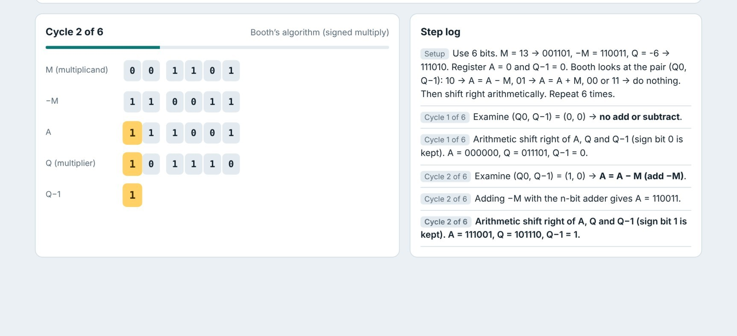

8 ÷ 3 (restoring). Q = 1000, M = 00011. After four cycles Q = 0010 (quotient 2) and A = 00010 (remainder 2); the result card checks 3 × 2 + 2 = 8.
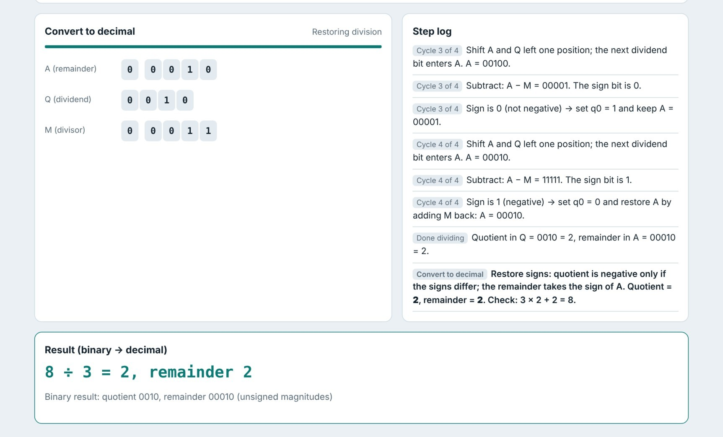
Figure 6 – Finished restoring division: quotient 2, remainder 2.

6. Interface, testing and limitations
Interface. Controls sit on top, registers on the left and the step log on the right (stacked on narrow screens). A cool bluegrey background with teal actions and amber active bits keeps “what is being worked on now” the brightest element. Motion only reflects algorithm progress and is disabled for users who prefer reduced motion. Light and dark themes follow the device; wide registers scroll inside their own row; invalid input (non-integers, values beyond ±2047, division by zero) gets a plain-language message.
Testing. For 1,500 random pairs in −2047…2047, the results of the adder, subtractor, Booth multiplier and restoring divider (6,000 comparisons) were compared with JavaScript’s own arithmetic; every one matched. Edge cases (−2047 × −2047, zero operands, 2047 × 2047, −1 and 1) passed, the slide examples were reproduced, and a headless Chromium run of all four operations reported no errors.
Limitations and future work. Inputs are limited to −2047…2047 and to integers. Natural extensions are IEEE 754 floatingpoint mode (sign, excess-127 exponent, 23-bit mantissa), carry look-ahead and non-restoring division variants, and a stepback button. Division truncates toward zero and the remainder takes the dividend’s sign.

7. Conclusion
The simulator follows the circuits of Module 3 – the full-adder chain, the XOR-based adder/subtractor, Booth’s algorithm and restoring division – and shows each one bit by bit and cycle by cycle. Separating calculation from display kept the code small, made it easy to test and gave smooth control over speed and stepping. It runs from a single file in any browser.

Appendix – Complete source code (binary-alu-simulator.html)
COA file 1 (index.html)

<!DOCTYPE html>
<html lang="en"><head><meta charset="utf-8">
<meta name="viewport" content="width=device-width, initial-scale=1, viewport-fit=cover">
<title>Binary ALU Simulator</title>
<style>
:root{box-sizing:border-box;padding-top:env(safe-area-inset-top,0px);padding-bottom:env(safe-area-inset-bottom,0px);
--bg:#eaf0f4;--card:#fff;--tx:#12202b;--mut:#5a6b78;--bd:#cfdae2;--ac:#0b7a75;--acx:#fff;--hl:#ffd166;--hlt:#3d2c00;--chg:#9fe3dc;--b0:#e3ebf0;--ok:#0b7a75;--warn:#c62828}
@media (prefers-color-scheme:dark){:root:not([data-theme="light"]){--bg:#0d1a22;--card:#14252f;--tx:#e4eef3;--mut:#8ea3b0;--bd:#25404f;--ac:#3cc9bd;--acx:#06201f;--hl:#e0a800;--hlt:#1d1500;--chg:#1f6b66;--b0:#1d3441;--ok:#3cc9bd;--warn:#ff8a80}}
:root[data-theme="dark"]{--bg:#0d1a22;--card:#14252f;--tx:#e4eef3;--mut:#8ea3b0;--bd:#25404f;--ac:#3cc9bd;--acx:#06201f;--hl:#e0a800;--hlt:#1d1500;--chg:#1f6b66;--b0:#1d3441;--ok:#3cc9bd;--warn:#ff8a80}
html{scroll-padding-top:env(safe-area-inset-top,0px)}
*{box-sizing:border-box}
body{margin:0;background:var(--bg);color:var(--tx);font:16px/1.5 system-ui,-apple-system,"Segoe UI",Roboto,sans-serif}
main{max-width:1100px;margin:0 auto;padding:20px 16px 48px}
h1{font-size:1.7rem;margin:0 0 4px;letter-spacing:-.02em}
.sub{color:var(--mut);margin:0 0 18px;max-width:62ch}
.card{background:var(--card);border:1px solid var(--bd);border-radius:12px;padding:16px}
.form{display:flex;flex-wrap:wrap;gap:12px;align-items:flex-end}
label{display:flex;flex-direction:column;font-size:.85rem;color:var(--mut);gap:4px}
input,select{font:inherit;font-size:1rem;padding:8px 10px;border:1px solid var(--bd);border-radius:8px;background:var(--bg);color:var(--tx);min-width:0}
input[type=number]{width:120px}input[type=range]{padding:0;width:130px}
button{font:inherit;font-weight:600;padding:9px 16px;border-radius:8px;border:1px solid var(--bd);background:var(--card);color:var(--tx);cursor:pointer}
button.go{background:var(--ac);color:var(--acx);border-color:var(--ac)}
button:disabled{opacity:.45;cursor:default}
button:focus-visible,input:focus-visible,select:focus-visible{outline:3px solid var(--hl);outline-offset:1px}
.err{color:var(--warn);min-height:1.4em;margin:8px 0 0;font-size:.9rem}
.grid{display:grid;grid-template-columns:1.25fr 1fr;gap:16px;margin-top:16px}
@media(max-width:820px){.grid{grid-template-columns:1fr}}
.top{display:flex;justify-content:space-between;gap:8px;flex-wrap:wrap;align-items:baseline}
.phase{font-weight:700}.algo{color:var(--mut);font-size:.85rem}
.bar{height:5px;background:var(--b0);border-radius:3px;margin:10px 0 14px;overflow:hidden}
.bar i{display:block;height:100%;width:0;background:var(--ac);transition:width .4s}
.reg{display:flex;align-items:center;gap:10px;margin:8px 0}
.rn{width:112px;flex:none;font-size:.82rem;color:var(--mut)}
.cells{overflow-x:auto;white-space:nowrap;padding:4px 2px}
.b{display:inline-grid;place-items:center;width:28px;height:34px;margin:0 1px;border-radius:6px;background:var(--b0);font:600 15px ui-monospace,SFMono-Regular,Menlo,Consolas,monospace;transition:background .35s,transform .35s}
.b.g{margin-left:9px}.b.sp{background:none}
.b.dim{color:var(--mut)}
.b.hl{background:var(--hl);color:var(--hlt);transform:scale(1.12)}
.b.chg{animation:pop .5s}
@keyframes pop{0%{background:var(--chg);transform:scale(1.3)}100%{transform:scale(1)}}
.note{font-size:.9rem;color:var(--mut);margin:10px 0 0;min-height:2.6em}
#log{max-height:440px;overflow-y:auto;font-size:.9rem}
.ln{padding:7px 0;border-bottom:1px solid var(--bd);animation:in .35s}
.ln.cur{font-weight:600}
.tag{display:inline-block;font-size:.75rem;background:var(--b0);border-radius:5px;padding:0 6px;margin-right:6px;color:var(--mut)}
@keyframes in{from{opacity:0;transform:translateX(10px)}to{opacity:1;transform:none}}
#res{margin-top:16px;display:none;border-color:var(--ac)}
#res .big{font-size:1.6rem;font-weight:700;color:var(--ok);font-family:ui-monospace,Menlo,Consolas,monospace}
.empty{color:var(--mut)}
h2{font-size:1rem;margin:0 0 6px}
@media(prefers-reduced-motion:reduce){*{animation:none!important;transition:none!important}}
</style></head><body><main>
<h1>Binary ALU simulator</h1>
<p class="sub">Enter two decimal integers, pick an operation and watch the arithmetic unit work in binary: ripple-carry addition, 2’s-complement subtraction, Booth’s multiplication and restoring division.</p>
<section class="card"><div class="form">
<label>Number A<input id="a" type="number" step="1" value="13"></label>
<label>Operation<select id="op"><option value="+">Add (+)</option><option value="-">Subtract (−)</option><option value="*" selected>Multiply (×)</option><option value="/">Divide (÷)</option></select></label>
<label>Number B<input id="b" type="number" step="1" value="-6"></label>
<label>Speed<input id="spd" type="range" min="1" max="10" value="6" aria-label="Speed"></label>
<button class="go" id="start">Start calculating</button>
<button id="pause" disabled>Pause</button><button id="next" disabled>Next step</button><button id="skip" disabled>Skip to result</button>
</div><p class="err" id="err" role="alert"></p></section>
<div class="grid">
<section class="card"><div class="top"><span class="phase" id="phase">Registers</span><span class="algo" id="algo"></span></div>
<div class="bar"><i id="prog"></i></div><div id="regs"><p class="empty">Press “Start calculating” to load the registers.</p></div><p class="note" id="note"></p></section>
<section class="card"><h2>Step log</h2><div id="log"><p class="empty">Each step appears here.</p></div></section>
</div>
<section class="card" id="res"><h2>Result (binary → decimal)</h2><div class="big" id="resv"></div><div id="resb" class="note"></div></section>
</main>
<script>
const $=id=>document.getElementById(id);
const sb=v=>{let n=1;while(v<-(2**(n-1))||v>=2**(n-1))n++;return n};
const bin=(v,n)=>(v&((1<<n)-1)).toString(2).padStart(n,"0");
const pi=s=>parseInt(s,2);
function dec(s,sg=true){const L=s.length;let t=[],tot=0;for(let i=0;i<L;i++)if(s[i]=="1"){const w=(sg&&i==0?-1:1)*2**(L-1-i);t.push(w);tot+=w}
return{tot,t:`${s} → ${t.length?t.map(w=>w<0?"− "+(-w)+" ":(t[0]<0&&w==t[0]?"":"+ ")+w+" ").join(""):"0 "}= <b>${tot}</b>`+(sg?` (leftmost bit has weight −2<sup>${L-1}</sup>)`:"")}}
const rg=(n,b,h,pad)=>({n,b,h:h||[],pad:pad||0});

function addSub(A,B,sub){
const r=sub?A-B:A+B,n=Math.max(4,sb(A),sb(B),sb(r)),S=[],x=bin(A,n),y=bin(B,n);
const all=[...Array(n).keys()];
S.push({p:"Setup",t:`Convert both numbers to ${n}-bit 2’s complement: A = ${A} → ${x}, B = ${B} → ${y}.`,r:[rg("X (A)",x,[],1),rg("Y (B)",y,[],1)]});
let yy=y,c=0;
if(sub){yy=[...y].map(d=>d^1).join("");c=1;
S.push({p:"Setup",t:`Subtract: control M = 1. The XOR gates complement every bit of B, and the initial carry c0 = 1, so the adder computes A + B̄ + 1 = A − B.`,r:[rg("X (A)",x,[],1),rg("Y = B̄",yy,all,1)]});}
else S.push({p:"Setup",t:`Add: control M = 0. B passes through the XOR gates unchanged and the initial carry c0 = 0.`,r:[rg("X (A)",x,[],1),rg("Y (B)",y,[],1)]});
const car=Array(n+1).fill("·"),sum=Array(n).fill("·");car[n]=String(c);
for(let i=0;i<n;i++){
const j=n-1-i,xi=+x[j],yi=+yy[j],ci=+car[n-i],s=xi^yi^ci,co=(yi&ci)|(xi&ci)|(xi&yi);
sum[j]=s;car[n-i-1]=co;
S.push({p:`Full adder ${i} of ${n-1}`,t:`Stage ${i}: x${i}=${xi}, y${i}=${yi}, c${i}=${ci} → s${i} = ${xi}⊕${yi}⊕${ci} = <b>${s}</b>; c${i+1} = (${yi}·${ci}) + (${xi}·${ci}) + (${xi}·${yi}) = <b>${co}</b>. The carry ripples to stage ${i+1}.`,
r:[rg("Carry c"+n+"…c0",car.join(""),[n-i-1,n-i]),rg("X",x,[j],1),rg("Y"+(sub?" (B̄)":""),yy,[j],1),rg("Sum S",sum.join(""),[j],1)]});}
const rb=sum.join("");
S.push({p:"Done adding",t:`All ${n} stages finished. Carry out c${n} is discarded in 2’s complement arithmetic (no overflow here). Result bits: ${rb}.`,r:[rg("Sum S",rb,[0],1)]});
const d=dec(rb);
S.push({p:"Convert to decimal",t:`Read the result as a signed number: ${d.t}`,r:[rg("Result",rb,[0])]});
return{S,algo:sub?"Adder/subtractor: XOR on B, c0 = M = 1":"Ripple-carry adder",fin:`${A} ${sub?"−":"+"} ${B} = ${d.tot}`,bits:`${rb} (${n}-bit 2’s complement)`};
}

function booth(A,B){
const n=Math.max(4,sb(A),sb(B))+1,S=[],M=bin(A,n),nM=bin(-A,n);
let Ar="0".repeat(n),q=bin(B,n),qm="0";
const R=(a,qq,m,ha,hq,hm)=>[rg("M (multiplicand)",M,[]),rg("−M",nM,[]),rg("A",a,ha),rg("Q (multiplier)",qq,hq),rg("Q−1",m,hm)];
S.push({p:"Setup",t:`Use ${n} bits. M = ${A} → ${M}, −M = ${nM}, Q = ${B} → ${q}. Register A = 0 and Q−1 = 0. Booth looks at the pair (Q0, Q−1): 10 → A = A − M, 01 → A = A + M, 00 or 11 → do nothing. Then shift right arithmetically. Repeat ${n} times.`,r:R(Ar,q,qm,[],[],[])});
for(let k=1;k<=n;k++){
const q0=q[n-1],pr=q0+qm;
const act=pr=="10"?"A = A − M (add −M)":pr=="01"?"A = A + M":"no add or subtract";
S.push({p:`Cycle ${k} of ${n}`,t:`Examine (Q0, Q−1) = (${q0}, ${qm}) → <b>${act}</b>.`,r:R(Ar,q,qm,[],[n-1],[0])});
if(pr=="10"||pr=="01"){Ar=bin(pi(Ar)+pi(pr=="10"?nM:M),n);
S.push({p:`Cycle ${k} of ${n}`,t:`${pr=="10"?"Adding −M":"Adding M"} with the n-bit adder gives A = ${Ar}.`,r:R(Ar,q,qm,all(n),[],[])});}
const sg=Ar[0],nq=Ar[n-1]+q.slice(0,n-1),nqm=q[n-1];Ar=sg+Ar.slice(0,n-1);q=nq;qm=nqm;
S.push({p:`Cycle ${k} of ${n}`,t:`Arithmetic shift right of A, Q and Q−1 (sign bit ${sg} is kept). A = ${Ar}, Q = ${q}, Q−1 = ${qm}.`,r:R(Ar,q,qm,[0],[0],[0])});}
const P=Ar+q,d=dec(P);
S.push({p:"Done multiplying",t:`After ${n} cycles the 2n-bit product is A:Q = ${P}.`,r:[rg("Product A:Q",P,[0])]});
S.push({p:"Convert to decimal",t:`Read the product as signed: ${d.t}`,r:[rg("Product A:Q",P,[0])]});
return{S,algo:"Booth’s algorithm (signed multiply)",fin:`${A} × ${B} = ${d.tot}`,bits:`${P} (${2*n}-bit 2’s complement)`};
}
function all(n){return[...Array(n).keys()]}

function divide(A,B){
const a=Math.abs(A),m=Math.abs(B),n=Math.max(4,a.toString(2).length,m.toString(2).length),S=[];
let Ar="0".repeat(n+1),Q=bin(a,n);const M="0"+bin(m,n);
const R=(a,q,ha,hq)=>[rg("A (remainder)",a,ha),rg("Q (dividend)",q,hq),rg("M (divisor)",M,[])];
S.push({p:"Setup",t:`Restoring division works on positive numbers, so use |A| = ${a} and |B| = ${m} (signs are fixed at the end). Q = ${Q}, M = ${M}, A = ${Ar}. A and M have one extra bit for the sign.`,r:R(Ar,Q,[],[])});
for(let k=1;k<=n;k++){
Ar=Ar.slice(1)+Q[0];Q=Q.slice(1)+"·";
S.push({p:`Cycle ${k} of ${n}`,t:`Shift A and Q left one position; the next dividend bit enters A. A = ${Ar}.`,r:R(Ar,Q,[n],[n-1])});
const t=bin(pi(Ar)-pi(M),n+1);
S.push({p:`Cycle ${k} of ${n}`,t:`Subtract: A − M = ${t}. The sign bit is ${t[0]}.`,r:R(t,Q,[0],[])});
if(t[0]=="1"){Q=Q.slice(0,n-1)+"0";
S.push({p:`Cycle ${k} of ${n}`,t:`Sign is 1 (negative) → set q0 = 0 and restore A by adding M back: A = ${Ar}.`,r:R(Ar,Q,all(n+1),[n-1])});}
else{Ar=t;Q=Q.slice(0,n-1)+"1";
S.push({p:`Cycle ${k} of ${n}`,t:`Sign is 0 (not negative) → set q0 = 1 and keep A = ${Ar}.`,r:R(Ar,Q,[],[n-1])});}
}
const qu=pi(Q),ru=pi(Ar),q=(A<0)!=(B<0)?-qu:qu,r=A<0?-ru:ru;
S.push({p:"Done dividing",t:`Quotient in Q = ${Q} = ${qu}, remainder in A = ${Ar} = ${ru}.`,r:R(Ar,Q,[],[])});
S.push({p:"Convert to decimal",t:`Restore signs: quotient is negative only if the signs differ; the remainder takes the sign of A. Quotient = <b>${q}</b>, remainder = <b>${r}</b>. Check: ${B} × ${q} + ${r} = ${B*q+r}.`,r:R(Ar,Q,[],[])});
return{S,algo:"Restoring division",fin:`${A} ÷ ${B} = ${q}, remainder ${r}`,bits:`quotient ${Q}, remainder ${Ar} (unsigned magnitudes)`};
}

let S=[],idx=-1,timer=null,playing=false,cur=null;
function render(i){
const s=S[i],pv=i>0?S[i-1]:null;
$("phase").textContent=s.p;$("prog").style.width=((i+1)/S.length*100)+"%";
$("regs").innerHTML=s.r.map(r=>{
const old=pv&&pv.r.find(o=>o.n==r.n),tot=r.pad+r.b.length;
let h=`<span class="b sp" style="width:${r.pad*30}px;${r.pad?"":"display:none"}"></span>`;
[...r.b].forEach((ch,k)=>{const g=r.pad+k,gap=g>0&&(tot-g)%4==0;
h+=`<i class="b${gap?" g":""}${ch=="·"?" dim":""}${r.h.includes(k)?" hl":""}${old&&old.b.length==r.b.length&&old.b[k]!=ch?" chg":""}">${ch}</i>`});
return`<div class="reg"><span class="rn">${r.n}</span><div class="cells">${h}</div></div>`}).join("");
$("note").innerHTML="";
const L=$("log");if(i==0)L.innerHTML="";
L.querySelectorAll(".cur").forEach(e=>e.classList.remove("cur"));
L.insertAdjacentHTML("beforeend",`<div class="ln cur"><span class="tag">${s.p}</span>${s.t}</div>`);L.scrollTop=L.scrollHeight;
if(i==S.length-1){$("resv").textContent=cur.fin;$("resb").textContent="Binary result: "+cur.bits;$("res").style.display="block";finish()}
}
function setBtns(run){$("pause").disabled=!run;$("next").disabled=!run;$("skip").disabled=!run}
function finish(){clearTimeout(timer);playing=false;setBtns(false)}
function tick(){if(!playing)return;if(idx+1>=S.length)return;render(++idx);if(playing&&idx+1<S.length)timer=setTimeout(tick,2300-$("spd").value*200)}
function start(){
const a=$("a").value,b=$("b").value,op=$("op").value,e=$("err");e.textContent="";
if(a===""||b===""||!/^-?\d+$/.test(a)||!/^-?\d+$/.test(b)){e.textContent="Enter whole numbers for A and B.";return}
const A=+a,B=+b;
if(Math.abs(A)>2047||Math.abs(B)>2047){e.textContent="Use numbers between −2047 and 2047 so the registers stay readable.";return}
if(op=="/"&&B===0){e.textContent="Cannot divide by zero. Change B.";return}
clearTimeout(timer);cur=op=="+"?addSub(A,B,0):op=="-"?addSub(A,B,1):op=="*"?booth(A,B):divide(A,B);
S=cur.S;idx=-1;$("algo").textContent=cur.algo;$("res").style.display="none";$("log").innerHTML="";
playing=true;$("pause").textContent="Pause";setBtns(true);tick();
}
$("start").onclick=start;
$("pause").onclick=()=>{if(playing){playing=false;clearTimeout(timer);$("pause").textContent="Resume"}else{playing=true;$("pause").textContent="Pause";timer=setTimeout(tick,100)}};
$("next").onclick=()=>{playing=false;clearTimeout(timer);$("pause").textContent="Resume";if(idx+1<S.length)render(++idx)};
$("skip").onclick=()=>{playing=false;clearTimeout(timer);while(idx+1<S.length)render(++idx)};
</script></body></html>

BINARY ADDITION:
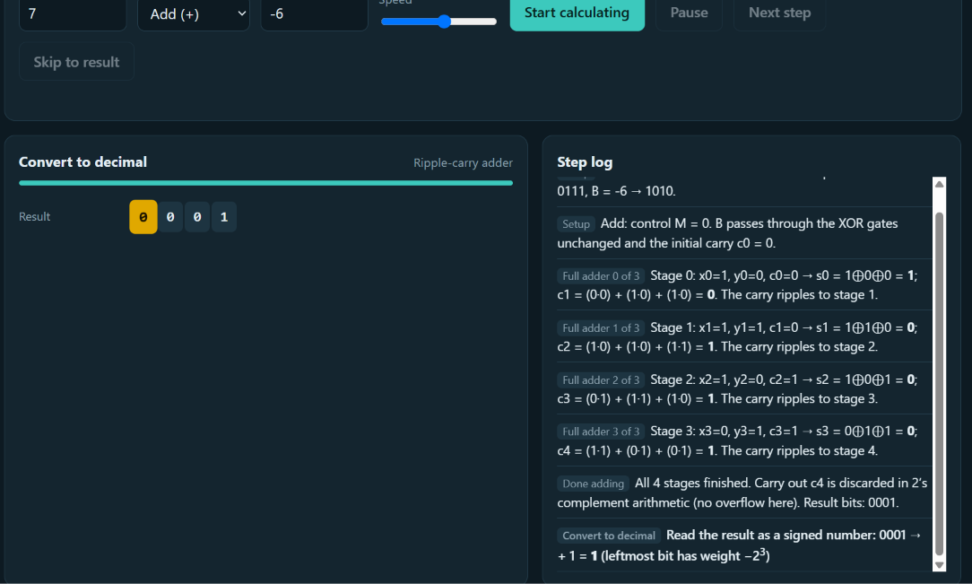

BINARY SUBSTRACTION:

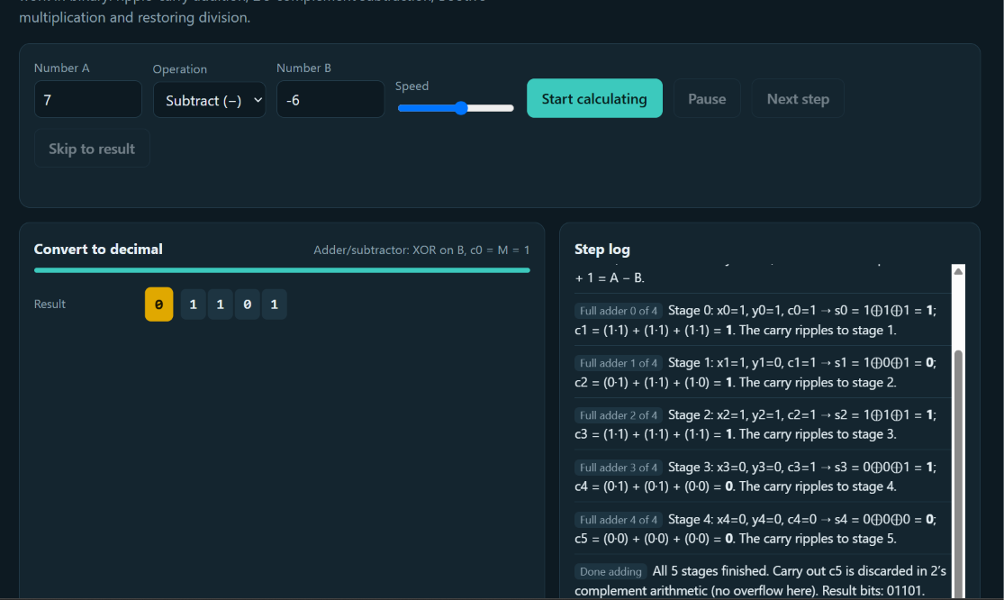

BINARY MULTIPLICATION:
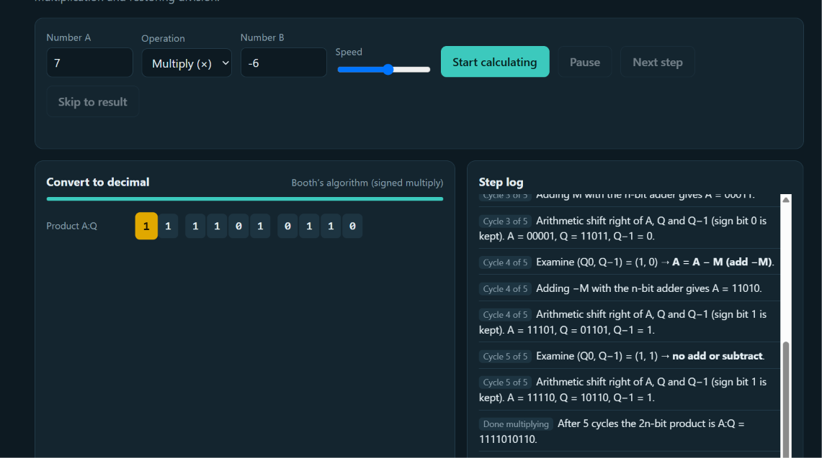

BINARY DIVISION:
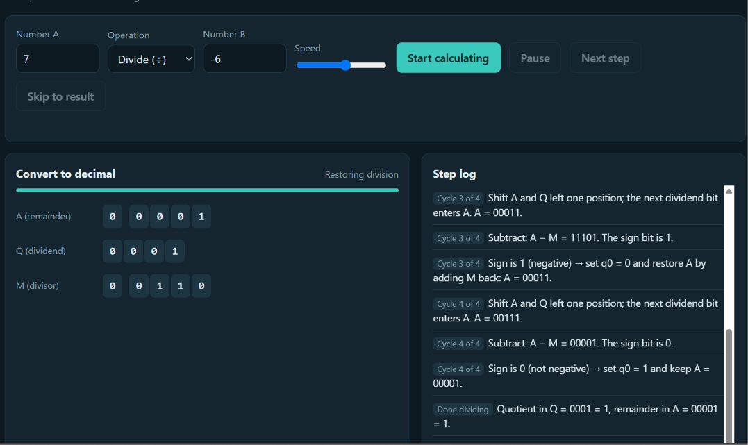

THANK YOU

